Student Skill Exchange & Academic Platform

Project Description

- Problem Identification

Project Title: Student Academic Support and Skill Exchange Platform

Literature Review:
(Admin, 2025), Many Students in higher education institutions struggle with academic stress and pressure risen from heavy coursework, assignments and examinations. Students also struggle to grasp the content they have learnt and apply them in today’s world. This is often caused by limited access to personalized academic support, poor time management, poor communication, writing and other basic skills they don’t learn in class. As result students get lower grades not because they lack intelligence.

At the same time, many skilled professionals and tutors having valuable knowledge face unemployment or limited income opportunities.

The project aims to reduce the gap between students seeking academic assistance and skilled individuals who can provide tutoring, mentorship and other academic related services.

Aims And Objectives

Aim: To build a prototype for the platform that connects students with qualified tutors and skilled professionals to help them with academic support, skill development and employment opportunities.

Objectives
- To provide students with access to academic support services.
- To help students improve their understanding and grades of difficult subjects.
- To connect students with professional tutors and skilled individuals.
- To create new employment opportunities for qualified tutors.
- To provide a secure platform where students and tutors can communicate and collaborate
- To support personalized learning experiences

- Project Scope
- Project Delivery
- Landing page
- Student and tutor registration page
- Student and tutor login page
- Student dashboard
- Tutor dashboard
- Search and Filtering system
- Tutor Hiring and request system
- Messaging system
- Payment feature
- AI integrated feature for recommendations
- Interactive prototype developed using Figma

- Project Exclusions
- Video Conferencing functionality
- Cryptocurrency payments
- Multi-country payment support
- Advanced AI chatbot

- Assumptions
- Users of the platform have reliable internet access
- Users have fundamental knowledge of web apps and digital devices
- Tutors are qualified in their areas of expertise
- Students are willing to use online academic support services
- Tutors are willing to make money online via the platform

- Development Methodology
The project is likely to be developed using the Agile Methodology. Agile methodology is a type software development lifecycle that involved the customer at each and every stage of the projects. It is best for modern software.

For the project agile selected because of the following reasons:

requirements may change during developing which will not be an issue to the developers as the methodology helps them to adapt and react instantly. Unlike other methodologies like Waterfall which only the requirements are stated once at the beginning and if they are not clearly communicated, they may result into some consequences when development.

  - Project Plan
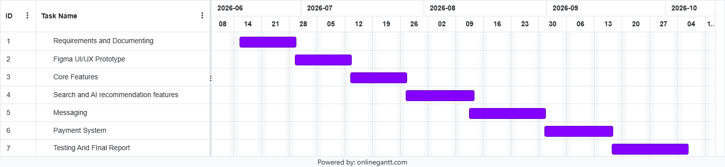

Requirements Specifications

Requirements Gathering Methods
According to (geeksforgeeks, 2026), gathering requirements is one the most crucial steps in project development. This is because it helps to understand what the project actually needs and what are the most crucial parts of the projects to be worked on. To ensure the “Student Academic Support and Skill Exchange Platform” meets the actual needs of its users, a combination of primary and secondary research methods was adopted to gather requirements.

- Primary Research (Online Surveys)
An online questionnaire was distributed to students from different universities to identify main academic challenges such as stress, lack of personalized support and difficulty finding affordable tutors. Surveys were chosen because they allow rapid collection of quantitative data from large sample size, ensuring the project addresses widespread student pain points rather than isolated issues.

- Secondary Research (Competitor Analysis)
This involved going through platforms like Fiverr, Cisco Academy and Preply and analyzing them in order to find industry-based features. Analyzing competitors ensures that the platform includes expected functionalities such as secure payment gateways, rating systems and messaging. This helps to identify gaps in the current market that this project can fill such as the integration for personalized tutor matching.

Functional Requirements
According to (geeksforgeeks, 2026), Functional requirements are requirements that describes what the system should do and how the users interact with it, involving all features and operation. As defined by (Begelow, 2020), those requirements dictate the system behavior, involving inputs, processes and outputs.

For the system functional requirements that have been established include the following:

- Authentication
The system shall allow students, Tutors and Admins to register with a unique email and password which will later be used to access their respective dashboards securely.
- Profile Management
The system shall allow Tutors to input andupdate their qualification, skills and hourly rates. It will also allow students to change their profile names and profile pictures.
- Search and AI Recommendations
The system shall allow students to search for Tutors using specific input filters for example subject and price range and display the matching profiles as output.
- Hiring Requests
The system shall enable students to send hiring request to Tutors and provide an interface for tutors to accept or reject these requests.
- Messaging
The system shall provide a real-time messaging interface which will allow students and tutors to communicate.
- Payments
The system shall process payments for tutoring sessions and generate transaction history for the Tutor.

Non-Functional Requirements
Non-functional requirements on the other hand defines how the system performs. (TpointTech, 2025), Emphasizes that while functional requirements ensure the system works, non-functional requirements focus on the system working effectively, reliably and securely which directly influences the overall user experience and system architecture.

The following are non-functional requirements that have been established for the platform:

- Performance
The search feature and AI recommendation engine shall process queries and return results within a short period of time to ensure a seamless user experience.

- Security
All user passwords must be hashed and payment details must be encrypted in the database to prevent unauthorized access.

- Usability
The user interface shall be responsive and user friendly. This to ensure that new user can navigate from the landing page to booking a tutor without getting lost regardless of what device they are using from phone, tablet to personal computer.

- Availability
The web application must be available all the time. This ensures that students can access academic support at any time of the day.

- Scalability
The system architecture shall be designed to handle huge number of users for instance 5,000 max concurrent users without being its performance being degraded or affected in any way.

Class Diagrams and Use Case Diagram
Use Case Diagram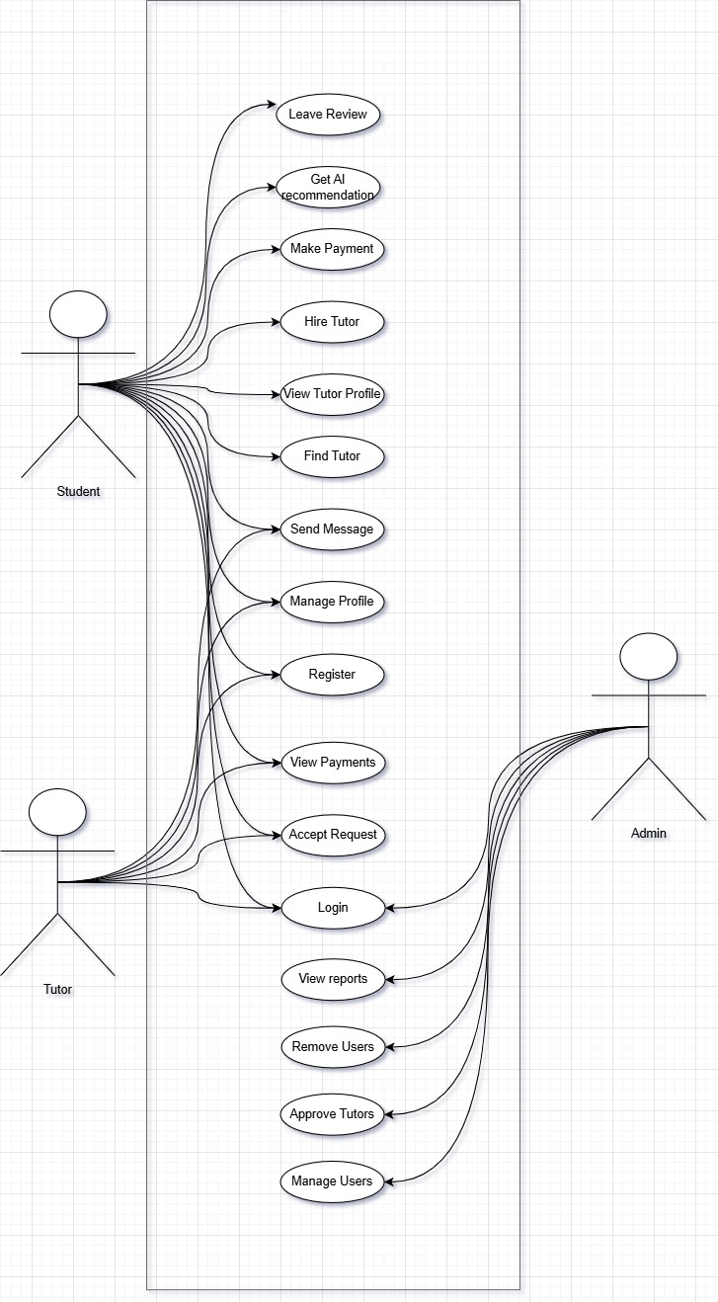

Class Diagram
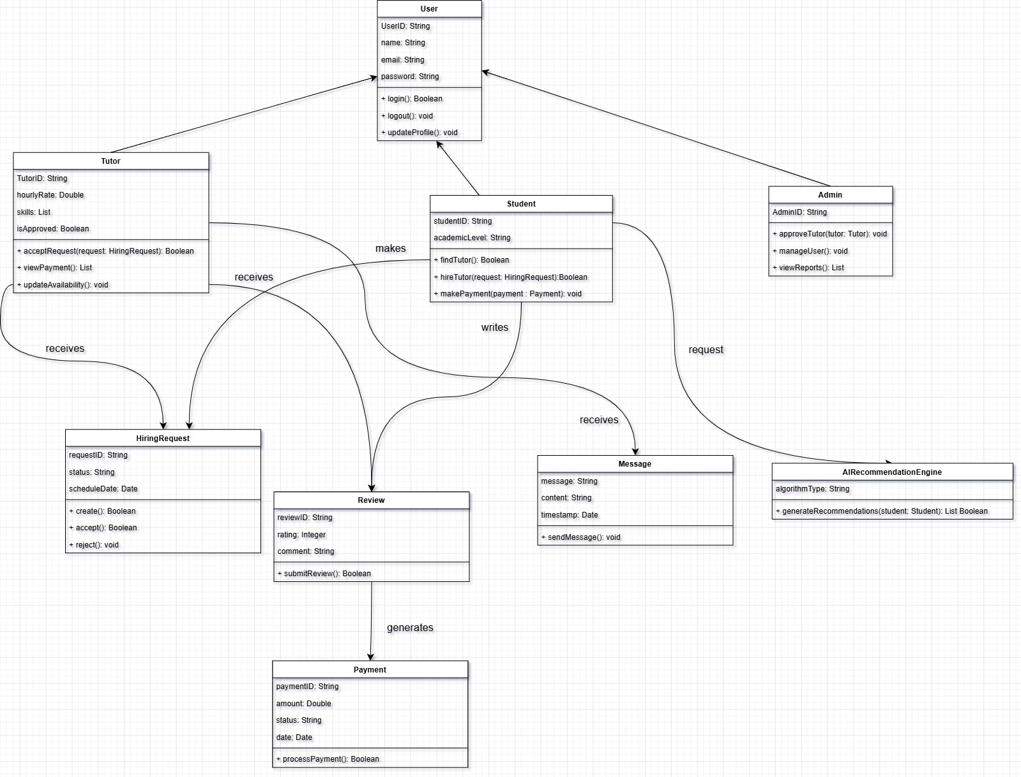

References
Admin, 2025. collegenp. [Online]
Available at: https://www.collegenp.com/article/most-common-problems-faced-by-students
[Accessed 06 June 2026].
Begelow, S. J., 2020. TechTarget. [Online]
Available at: https://www.techtarget.com/searchsoftwarequality/answer/Functional-and-nonfunctional-requirements
[Accessed 15 June 2026].
geeksforgeeks, 2026. geeksforgeeks. [Online]
Available at: https://www.geeksforgeeks.org/software-engineering/functional-vs-non-functional-requirements/
[Accessed 15 June 2026].
TpointTech, 2025. Tpointtech. [Online]
Available at: https://www.tpointtech.com/functional-and-non-functional-requirements-in-software-engineering
[Accessed 15 June 2026].

